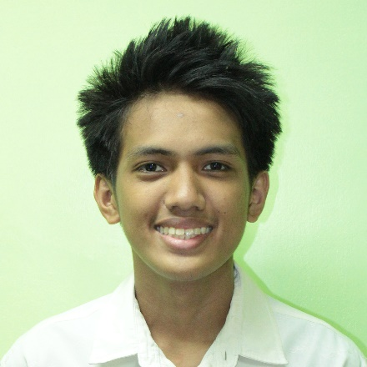**ALEX AUSTIN S. QUINTIN**

home2-512 001 Rocavilla Ave., Camella Homes, Noveleta, Cavite

phone-symbol-2 +63 905 332 1591

27630 alexaustinquintin@gmail.com

**JOB DESCRIPTION**

To be hired in a position wherein I can improve my skills in Information Communication Technology, to gain knowledge and experience about my future career, to increase my confidence and communication skills, to learn how to be a professional IT staff

**QUALIFICATIONS**

* Responsible, resourceful, honest, dedicated, and hardworking
* Knowledgeable in Programming and Database Languages (C++, Visual Basic, MySQL, Oracle)
* Knowledgeable in Web Development Tools (HTML, CSS, PHP)
* Knowledgeable in Graphic Designing App (Adobe Photoshop)
* Willing to learn and expand skills and understanding.
* Takes initiative and able to work independently with minimal supervision.
* Proficient in English Language (Both oral and written)

**WORK EXPERIENCE**

**READS (Recoletos Educational Assistance for Deserving Students) Grantee**

*San Sebastian College – Recoletos de Cavite*

Re-COP (Recoletos Community Outreach Program) Office

June 2015 – October 2017

* Performs encoding, data/document collection, report writing functions and other duties from time to time.
* Files all pertinent documents according to the office’s filing system.
* Assists in outreach activities of the institution, department, and organization/s.
* Designs certificates, newsletters and tarpaulins as needed.
* Maintains cleanliness and orderliness of the office.

Campus Ministry Office – Main Campus

November 2017 – Present

* Performs and support functions that facilitate the office and operations pertinent to the Religious and Liturgical activities of the Institution.
* Serves as front liner of the office by receiving visitors and assisting the concerns of the students.
* Assists in filing all important documents according to the office’s filing system, and retrieve filed documents when needed.
* Assists the Campus Ministry Staff in preparations for every religious and liturgical activity.
* Designs certificates, mass booklet/s, and tarpaulins as needed.
* Maintains cleanliness and orderliness daily in the Chapel and the Campus Ministry Office.

**SEMINARS AND TRAININGS**

2017 **Tech Tutor 9**

*SM Megatrade Hall 1 & 2*

*Sept. 27, 2017*

**Cavite Youth IT Convention**

*SM City Bacoor*

*Sept. 8, 2017*

2016 **Tech Tutor 8**

*SM Megatrade Hall 1 & 2*

*Sept. 28, 2016*

2016 **Tech Tutor 7**

*SM Megatrade Hall 1 & 2*

*Sept. 30, 2015*

**AFFILIATIONS**

**READS (Recoletos Educational Assistance for Deserving Students)**

* Member 2015 – Present
* VP for Publication and Communication (PRO) 2017 – Present

**JPCS (Junior Philippine Computer Society)**

* Member 2015 – Present

**EDUCATIONAL BACKGROUND**

**TERTIARY** San Sebastian College – Recoletosde Cavite

Manila - Cavite Road, Sta. Cruz, Cavite City, Cavite

June 2015 – Present

**SECONDARY** Patnubay Academy

San Juan I, Noveleta Cavite

2011 – 2015

**REFERENCES**

**Engr. Tommy A. Ditucalan**

OIC, College of Engineering, Computer Studies and Technology

San Sebastian College – Recoletos de Cavite

(046) 431-0861 loc. 789

**Mr. Antonio C. Co, MBA**

Head, Computer Studies Department

San Sebastian College – Recoletos de Cavite

(046) 431-0861 loc. 745

**Rev. Fr. Samuel L. Eyas, OAR**

Vice President for Religious Affairs

San Sebastian College – Recoletos de Cavite

(046) 431-0861 loc. 742

**ALEX AUSTIN S. QUINTIN**

**Applicant**